How To Identify Which Model of Raspberry PI you have:

Original document;

<https://www.element14.com/community/community/raspberry-pi/blog/2016/11/21/how-to-identify-which-model-of-the-raspberry-pi-you-have>

# [How To Identify Which Model Of The Raspberry Pi You Have](https://www.element14.com/community/community/raspberry-pi/blog/2016/11/21/how-to-identify-which-model-of-the-raspberry-pi-you-have)

Posted by [CharlesGantt](https://www.element14.com/community/people/CharlesGantt) in [Raspberry Pi](https://www.element14.com/community/community/raspberry-pi/blog) on Nov 21, 2016 3:54:35 PM



When the first Raspberry Pi was released in February 2012 it revolutionized the way makers around the world made things, and it completely changed the landscape of the development board world, and continues to do so even today. As of November 2016 there are seven different versions of the Raspberry Pi that are carried by Element14. While this is a major win for the maker world, it does create quite the challenge for anyone new to Raspberry Pi who might be trying to figure out what board they have because some of the boards are almost identical to each other at first glance. I hope this article will clear up the confusion for everyone, and help those reading this to get on with their projects.

Let’s take a moment to familiarize ourselves with the different single board computers that make up the Raspberry Pi family. As I mentioned in the first paragraph, we currently carry seven different development boards from the Raspberry Pi lineup, and I have created a table below that list the features of each board for quick comparison. Much thanks to Lui ([lui_gough](https://www.element14.com/community/people/lui_gough)) for the original version of this.

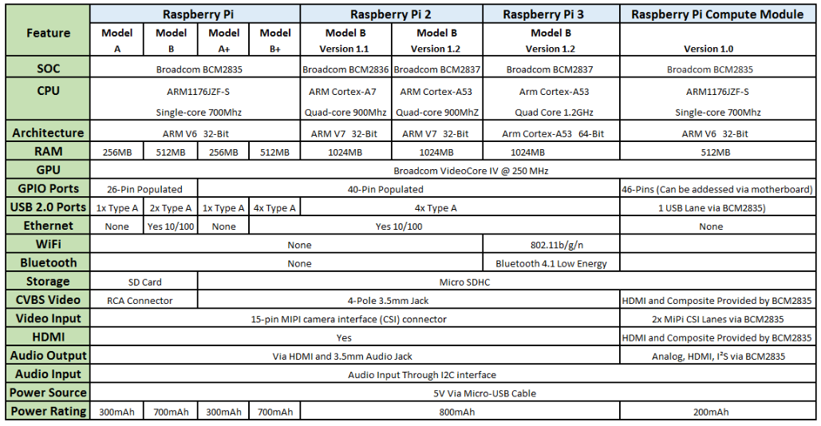

## **Identifying the Raspberry Pi Model A, A+, B, and B+ Single Board Computers**

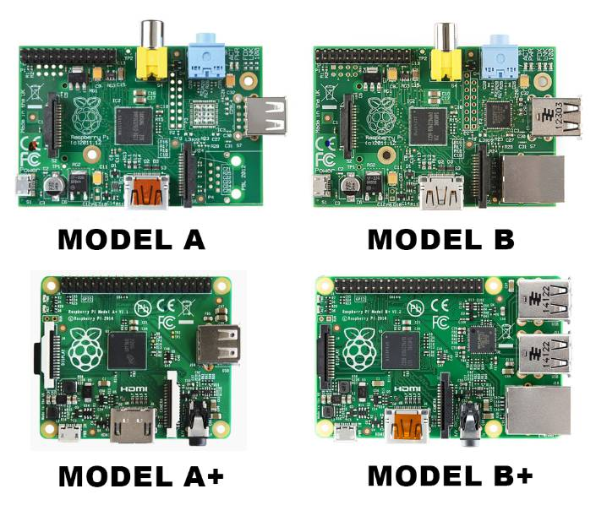

Early Versions of the Raspberry Pi featured the Broadcom BCM2853 SoC which was based on an ARM1176JZF-S CPU that was built on the ARM V6 32-Bit architecture. These boards, the Model A, A+ B, and B+, were all clocked to 700Mhz, and featured a Micro-USB connector for power. The less feature rich Model A boards can be identified by their lack of an Ethernet jack, with further identification being made by the shape of the board. The Model A is a rectangle, while the A+ is square in shape. Both the Model B and B+ boards are rectangular in shape, and do feature a single 10/100 Ethernet jack. Additionally, the Model B and B+ boards house an, at the time, impressive 512MB of SDRAM, with the Model A boards both featuring just 256MB of SDRAM. To further distinguish between these four early models, the Model A and B boards featured a yellow RCA Composite Video Connector and a full-sized SD card slot, while the A+ and B+ boards switched to a 4-pole 3.5mm jack and mico-SD card slot to save space. All boards should have their model screen printed on the front of the PCB. The model B+ also saw its Micro-USB port relocated to the side of the board alongside the HDMI port.

## **Identifying the Raspberry Pi 2 Model B Boards and the Raspberry Pi 3**

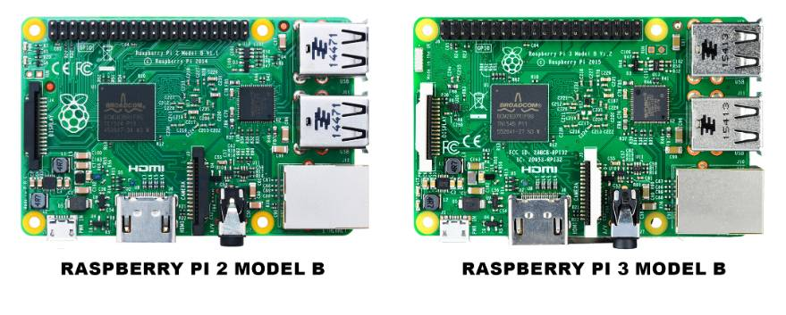

Discerning between the Raspberry Pi 2 Model B Version 1.1 and Version 1.2 is a bit harder to do because the physical layout of the board did not change, other than the Broadcom SoC being an updated model on Version 1.2. The easiest way to tell the difference between the two boards is to check the white screen print on the front of the board. Under the GPIO header pins, the boards model, and version number will be listed. If for some reason this information is missing, version 1.1 will feature a Broadcom BCM 2836 SoC, while version 1.2 will feature the Broadcom BCM2837 SoC. The Raspberry Pi looks almost identical to these two boards as well, and will also be easily identified by the screen printing on the front of the board. Note that version 1.2 of the Raspberry 2 Model B board features the same Broadcom BCM2837 SoC as the Raspberry Pi 3 Model B. If you are unsure of which of these two boards you have, you can as a last resort, check for two small copper pads under and to the right of the GPIO Pins. The pad on the left will be a square, while the pad on the right will be a circle. If your board has these copper pads, it is most likely a Raspberry Pi 3 Model B.

## **Identifying Which Raspberry Pi You Have Without Looking At The Board**

If by chance you do not have physical access to your Raspberry Pi and you still need to know which version it is, you can take the following steps to figure things out. From the terminal, enter the following command.

$ cat/proc/cpuinfo

This will spit out a string of numbers, and by comparing the last four digits to the revision number in the table below, you can determine the board, board version, RAM, and manufacturer quick and easily.

